Multi-platform Notification Facilitation Ultimate Express Plug-In for MS Teams®

Rodrigo Euan Briceño

Facultad de Matemáticas

Universidad Autónoma de Yucatán

Ricardo Kú Lozano

Facultad de Matemáticas

Universidad Autónoma de Yucatán

Fernando Rodríguez Díaz

Facultad de Matemáticas  
Universidad Autónoma de Yucatán

Guillermo Medina Gamboa

Facultad de Matemáticas

Universidad Autónoma de Yucatán

***Abstract*—This article proposes a plug-in made for Microsoft Teams which is meant to help students organization through different scholar platforms during COVID-19 pandemic, since this global situation made us go home school with no proper organization.**

***Index Terms*—online, school, home school, platforms, integration.**

***Resumen*—Este artículo propone una extensión hecha para Microsoft Teams que está pensado para ayudar a la organización de los estudiantes a través de todas las plataformas escolares durante la pandemia del COVID-19, ya que esta situación global nos hizo pasar a un entorno de clases online sin organización adecuada.**

***Palabras Clave*—en línea, escuela, escuela en casa, plataformas, integración.**

# INTRODUCTION

T

The pandemic caused by COVID-19 has hit not only economic and social aspects of our daily lives, but also school at all levels.

College students are an important part of scholar community, not only in volume but they are also the most important segment to take into consideration given that a college drop is less likely to recover, and college grade is also the most important learning opportunity since students after college become professionals, who need to be as prepared as previous generations that took a fully on site-career.

Because there was no background experience from most professors, tools to be used were not clear, speaking about Facultad de Matemáticas of Universidad Autónoma de Yucatán, every professor was able to select any platform or platforms they like, this led to students having up to five different platforms a semester for online assignatures.

Moving to online classes have resulted in many problems, some of which we are planning to resolve with this plug-in.

## *Objective*

Our main objective is to help students organize no matter how many different platforms their professors decide to manage. Making an integration for the most common platforms in order to have everything in the same place.

## *Justification*

* Every assignature uses a different platform: there is a variety of online school platforms and for Facultad de Matemáticas it is not mandatory to use one, which makes every professor pick whichever they think is suitable for the subject. A student could end up using four different platforms for one semester, making them have to switch between different ones and in some cases not being noticed about certain activities or announcements.
* Some assignatures use more than one platform: having to use different platforms for the same semester can be problematic, but there is a worse scenario where a professor decides to use multiple platforms for the same subject, it could be one for messaging, another one for virtual sessions and a third one for work deliveries.
* Resources: depending on the student and their context, they can spend more or less time on the computer, but economical resources are a key factor even for future TI professionals. We are aware that sometimes students have to study from a low-profile laptop without great specs. Online school platforms tend to be heavy but manageable for most computers, the issue really comes with multi-tasking. We can see students using 4 GB memory computers which are not capable of efficient multi-tasking between heavy platforms, they could just use one at the team, making it more complicated to stay tuned of their other three subjects if they happen to be on a different platform.
* The power of integration: it is not surprising that many students even with proper studying tools are not always tuned to all the platforms, given that it is not just one. Integration will help by having only one platform running which will notify if something happens on other platforms. Doing this would make students be notified on time if an assignment is set or it is close to the deadline.

# Marco Teórico

[1] An interesting article which analyzes how students integrate and perform towards three different platforms. These results highly contributed to the aim of our plug-in, given that 71.3% of global students think that handling all three MS Teams, Moodle and Zoom is inconvenient. Authors agree that there is a need to integrate these platforms in order to make task solving smoother for students.

[2] Without any IT objective, this paper talks about challenges and opportunities for online education’s obligated evolution. It shows how hard it can be for some countries (case of study: India) to have proper resources for managing multiple online obligations. Having said this article is not about IT, we could abstract that even when a measurement were to be taken by governments (as suggested by author), there won’t be global high end devices for all students and we have to somehow lower hardware requirements.

[3] This is a quantitative study of MS Teams as a platform itself. Before choosing a platform for our plug-in, the investigation was about what was the prefered platform for most professors given that they get to pick the course platform and its complements. Results were overwhelmingly favorable for MS Teams, showing around 80% preference to this platform for almost every evaluated aspect.

[4] Even when this is a chinese study, collected data can be abstracted to similar difficulties FMAT students could face. Chinese online education is a bit different from the rest of the world, since they use their own platforms but this helps us to realize some universal needs an user may have. At the end, this user satisfaction analysis became our auto-recording feature.

# Materials and methodology

## *Problems and definition of the project*

Moving to online classes have resulted in many problems, one of them is that the school never has an exact plan for remote classes and that's why many professors use every platform they know how to use. The problem with this was that students have to check every platform where the activities were uploaded, resulting in an increase of failure rate.

## *Determination of Requirements*

The emphasis in this section was important, because this serves as the basis of the project and what it wants to achieve. For the identification of requirements, we rely on the process of identification of persons.

* User requirements:In this project we have only one type of user, which can interact with the main modules of the project.
* The student that is a full time studies and part-time employee: This type of user needs to reduce the impact of academic dynamics on his/her education. Semesters being taken remotely won’t come back unless he/she retakes which implies losing time and finishing college almost a year later than expected.

The project consist in 2 main functionalities:

* Notify and get a kanban for the user when a new activity is uploaded in the platform he has logged-in in the plug-in of MS Teams.
* Autosave every video recorded in MS Teams on a certain local direction or online platform.

## *Design of the graphical interface*

Knowing the specific needs of users and the required functionalities, it was possible to develop a graphical interface to reconcile the ideas raised. Among the different approaches, the following stand out:

* Separation for each platform: We consider it important, as the original platform seemed intimidating at first glance to anyone, as notifications appeared from a start and there was no menu
* Notification feed like a kanban: We consider that representing the activities upcoming, active and close on a kanban was clear to understand the state of each activity.

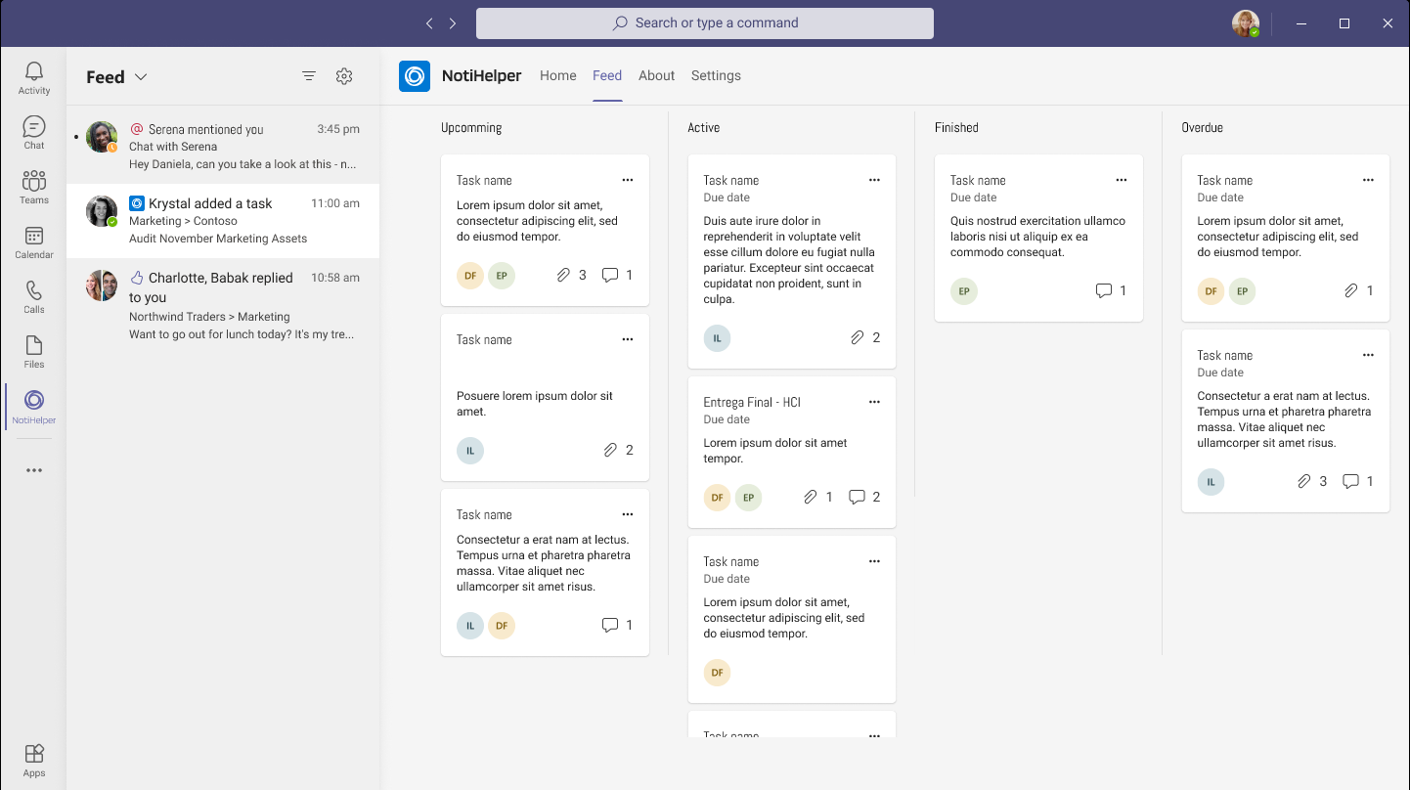

## *Development of the application prototype*

Taking into account the above considerations, prototypes of the user interfaces for the Home pages and those needed to carry out the notification feed were developed. In the first instance we worked with low fidelity prototypes in such a way that we could appreciate the integration and spatiality of the elements that we consider relevant to include. Later, in order to use them in our usability tests, we proceeded to create high fidelity prototypes based on the Microsoft UI kit from figma.

## *Usability* Test

Due to the contingency caused by the COVID-19 pandemic, we had to limit ourselves to perform the usability tests remotely. To choose the users who were going to be subjects of the tests, the students of software engineering of the faculty of mathematics of the Autonomous University of Yucatan were considered, according to the criteria compiled by our documents of Persona. Following the nature and approach that was decided to give to the project, we believe that the tests to be carried out should revolve around three attributes of usability: Efficiency, Satisfaction and Effectiveness.

To measure the satisfaction and credibility of the test, surveys were used with great relevance within the field of FMAT, which are the System Usability Scale and ASQ(After-Scenario Questionnaire). Two metrics were used to measure efficiency and effectiveness: Overall Relative Efficiency,Time Based Efficiency and Error-free rate. These metrics focus on collecting the times the user completes the measured tasks.

# Results

After testing with 4 users and focusing on usability attributes with their respective metrics, the results were mostly favorable: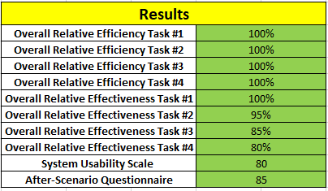

The data regarding the efficiency of the system indicate that the processes were very intuitive and without any need or effort of learning. Similarly, the appearance presented in the interfaces managed to be tasteful to users. In addition to the objective data collected, several observations were found in the tests performed that we consider important. One of the most relevant was that users expected to receive feedback when making changes to the auto-save function, as well as removing the default filtering of notifications.

# Conclusión

This project made it really clear how important non-functional requirements are when it comes to user experience. Feedback and ergonomy are key factors to consider if we want our system to satisfy usability minimum requirements.

By applying heuristic principles, we can ensure that our UX will be enjoyable, intuitive or usable at worst. We had the opportunity to see how a little pop up notice feedback we were missing, led to frustration from the user, the feeling dramatically changed and the system no longer gives the user this responsive-app feeling.

Requirements traceability takes a big importance when a user-centered design methodology is to be applied. The team has to be meticulous with original requirements, its evolution and the addition, when strictly needed, of new requirements when the process has started. Requirement definition is not the opposite of changes when using a spiral model, but major discrepancies between first idea and evolved project could lead to confusion between team members if changes were not properly documented.

The problem resulting from not being able to integrate all of our platforms was not as big as we thought for software engineering students, but it was still there and something to solve for part-time workers. We are confident that this plug-in with proper modifications given tests, would really benefit the persona we are focused on by having a platform sit in the background which notifies anything happening in student life while our persona is working.

References

1. Alameri, J., Masadeh, R., Hamadallah, E., Ismail, H. B., & Fakhouri, H. N. (2020). Students' Perceptions of E-learning platforms (Moodle, Microsoft Teams and Zoom platforms) in The University of Jordan Education and its Relation to self-study and Academic Achievement During COVID-19 pandemic. Journal ISSN, 2692, 2800.
2. Dubey. P & Pandey. D (2020). Distance learning in higher education during pandemic: challenges and opportunities. International Journal of Indian Psychology, 8(2), 43-46. DIP:18.01.204/20200802, DOI:10.25215/0802.204
3. Saranya A. K (2020). A Critical Study On The Efficiency Of Microsoft Teams In Online

Education. in Research Scholar School of Civil Engineering, VIT, Vellore-632014, India.

1. Chen T, Peng L, Yin X, Rong J, Yang J, Cong G (2020). Analysis of User Satisfaction with Online Education Platforms in China during the COVID-19 Pandemic. Healthcare. ; 8(3):200. https://doi.org/10.3390/healthcare8030200

